1. **Create the React App**

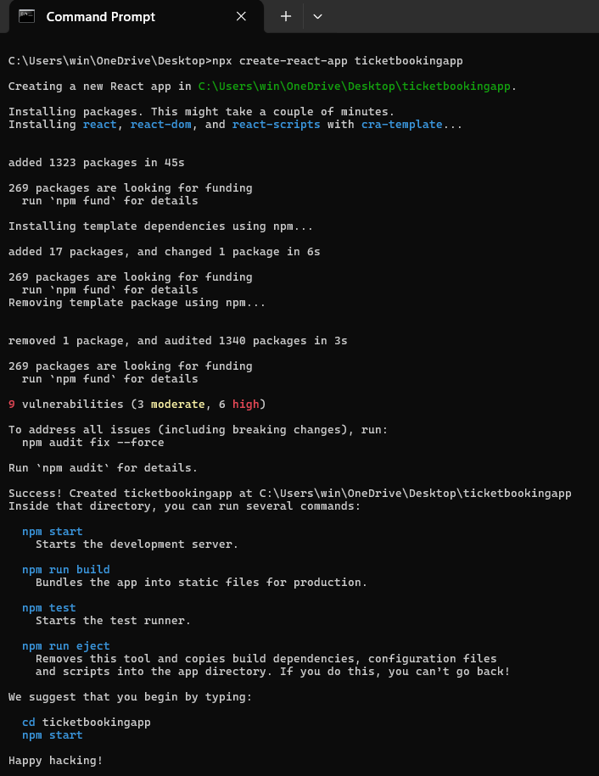

1. **Project Structure :**

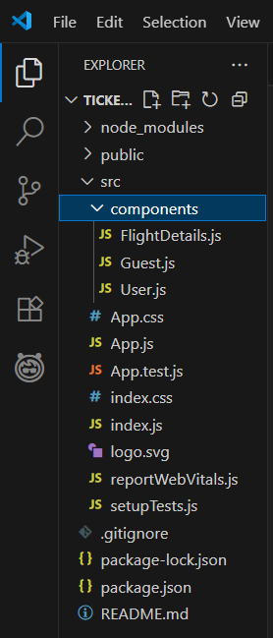

1. **Create Components :**

**Guest.js**

import React from 'react';

function Guest({ onLogin }) {

  return (

    <div>

      <h2>Welcome, Guest!</h2>

      <p>You can browse flight details but booking is disabled.</p>

      <button onClick={onLogin}>Login</button>

    </div>

  );

}

export default Guest;

**User.js**

import React from 'react';

function User({ onLogout }) {

  return (

    <div>

      <h2>Welcome, User!</h2>

      <p>You can now book flights!</p>

      <button onClick={onLogout}>Logout</button>

    </div>

  );

}

export default User;

**FlightDetails.js**

import React from 'react';

function FlightDetails() {

  return (

    <div>

      <h3>Flight Details</h3>

      <ul>

        <li>Flight A - 10:00 AM</li>

        <li>Flight B - 12:00 PM</li>

        <li>Flight C - 3:00 PM</li>

      </ul>

    </div>

  );

}

export default FlightDetails;

1. **Update App.js with Conditional Rendering:**

import React, { useState } from 'react';

import Guest from './components/Guest';

import User from './components/User';

import FlightDetails from './components/FlightDetails';

function App() {

  const [isLoggedIn, setIsLoggedIn] = useState(false);

  const handleLogin = () => setIsLoggedIn(true);

  const handleLogout = () => setIsLoggedIn(false);

  return (

    <div>

      <h1>Ticket Booking App</h1>

      <FlightDetails />

      {isLoggedIn ? (

        <User onLogout={handleLogout} />

      ) : (

        <Guest onLogin={handleLogin} />

      )}

    </div>

  );

}

export default App;

1. **Output :**

